**Recording Audio Over Zoom**

1. Login to your Zoom profile by visiting <https://deloitte.zoom.us/> page.
2. Select “**Access your Deloitte Zoom account**”.

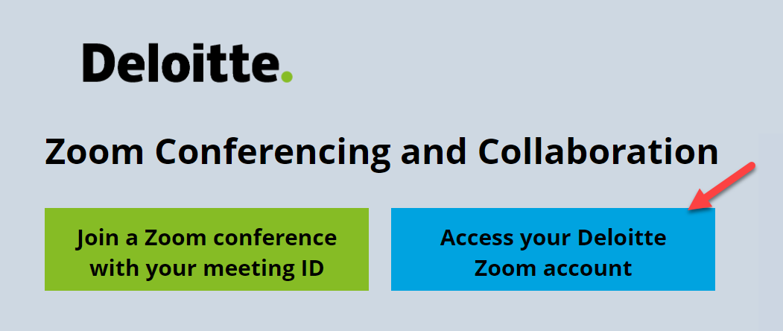

1. Click on the “**Settings**” option on the left and select “**Recording**” option on the right.

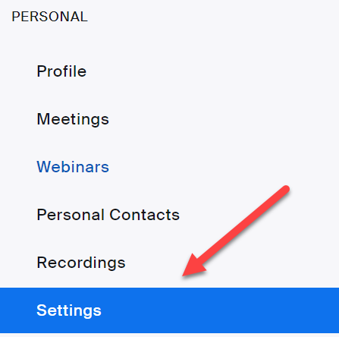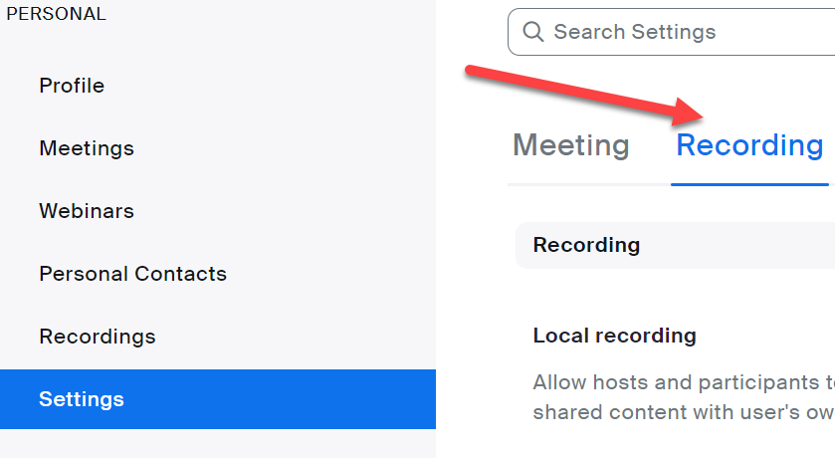

1. Under “**Cloud Recording**” option uncheck all the boxes and check only **Record audio-only** files and click on save.

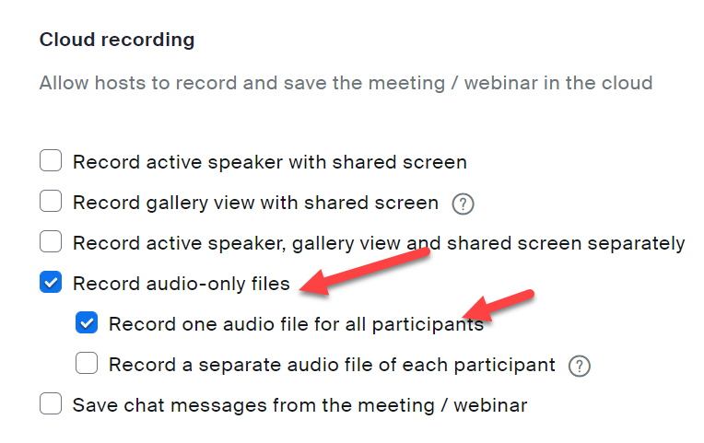

1. Click on “**Meetings**” option and select “**Schedule a Meeting**” to start a new meeting for your recording.

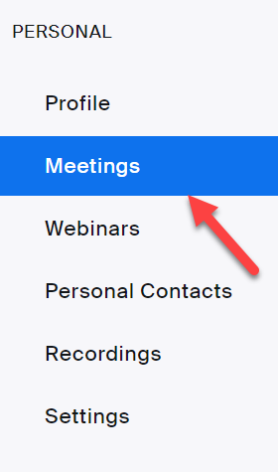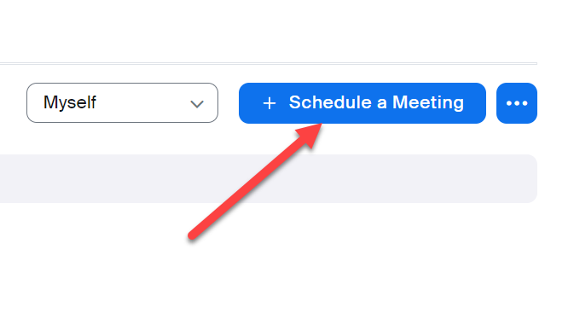

1. Once you are ready, click on **start recording and pause / stop according** to the requirement.

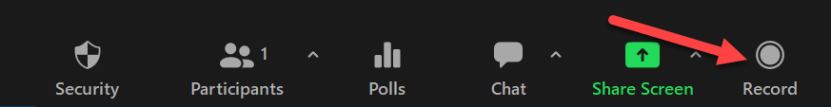

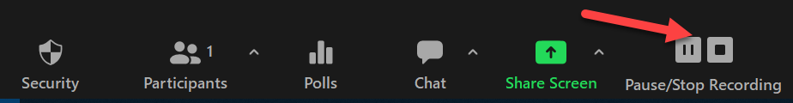

1. Once you have clicked on **stop recording**, the recording file will be transcoded and be available on your Zoom profile page.



1. Login to your Zoom account by visiting <https://deloitte.zoom.us/> page.
2. Select the “**Recordings**” option on the left and you should see the recording on the right side.

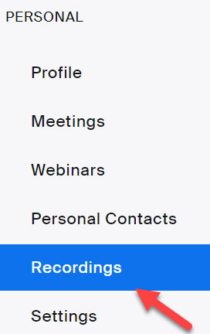

1. Click on the respective recording and select “**Audio Only**” option to download the audio file of your recording.

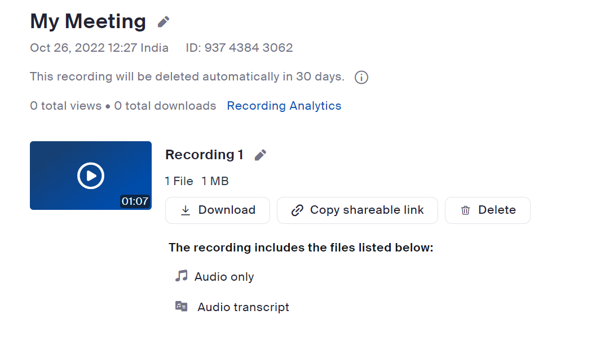

1. Make sure you revert back the settings of the recording once the recording for the audio book has been completed.

